Question 1: Creating and Renaming Files/Directories:
[root@localhost ~]# pwd
/root
[root@localhost ~]# ls -ltr
total 4
-rw-------. 1 root root 695 Aug 2 10:49 anaconda-ks.cfg
[root@localhost ~]# mkdir test_dir
[root@localhost ~]# ls -ltr
total 4
-rw-------. 1 root root 695 Aug 2 10:49 anaconda-ks.cfg
drwxr-xr-x. 2 root root 6 Aug 18 22:46 test_dir
[root@localhost ~]# cd test_dir/
[root@localhost test_dir]# pwd
/root/test_dir
[root@localhost test_dir]# touch example.txt
[root@localhost test_dir]# ls -ltr
total 0
-rw-r--r--. 1 root root 0 Aug 18 22:47 example.txt
[root@localhost test_dir]# mv example.txt renamed_example.txt
[root@localhost test_dir]# ls -ltr
total 0
-rw-r--r--. 1 root root 0 Aug 18 22:47 renamed_example.txt
[root@localhost test_dir]#

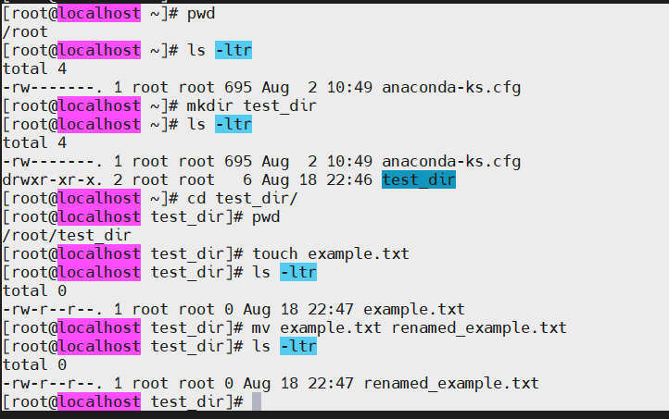

2. Viewing File Contents

[root@localhost ~]# cat /etc/passwd
root:x:0:0:root:/root:/bin/bash
bin:x:1:1:bin:/bin:/sbin/nologin
daemon:x:2:2:daemon:/sbin:/sbin/nologin
adm:x:3:4:adm:/var/adm:/sbin/nologin
lp:x:4:7:lp:/var/spool/lpd:/sbin/nologin
sync:x:5:0:sync:/sbin:/bin/sync
shutdown:x:6:0:shutdown:/sbin:/sbin/shutdown
halt:x:7:0:halt:/sbin:/sbin/halt
mail:x:8:12:mail:/var/spool/mail:/sbin/nologin
operator:x:11:0:operator:/root:/sbin/nologin
games:x:12:100:games:/usr/games:/sbin/nologin
ftp:x:14:50:FTP User:/var/ftp:/sbin/nologin
nobody:x:65534:65534:Kernel Overflow User:/:/sbin/nologin
systemd-coredump:x:999:997:systemd Core Dumper:/:/sbin/nologin
dbus:x:81:81:System message bus:/:/sbin/nologin
polkitd:x:998:996:User for polkitd:/:/sbin/nologin
sssd:x:997:995:User for sssd:/:/sbin/nologin
tss:x:59:59:Account used for TPM access:/:/usr/sbin/nologin
chrony:x:996:994:chrony system user:/var/lib/chrony:/sbin/nologin
sshd:x:74:74:Privilege-separated SSH:/usr/share/empty.sshd:/usr/sbin/nologin
rtkit:x:172:172:RealtimeKit:/:/sbin/nologin
geoclue:x:995:992:User for geoclue:/var/lib/geoclue:/sbin/nologin
flatpak:x:994:991:Flatpak system helper:/:/usr/sbin/nologin
pipewire:x:990:990:PipeWire System Daemon:/run/pipewire:/usr/sbin/nologin
jenkins:x:989:989:Jenkins Automation Server:/var/lib/jenkins:/bin/false

[root@localhost ~]# head -5 /etc/passwd
root:x:0:0:root:/root:/bin/bash
bin:x:1:1:bin:/bin:/sbin/nologin
daemon:x:2:2:daemon:/sbin:/sbin/nologin
adm:x:3:4:adm:/var/adm:/sbin/nologin
lp:x:4:7:lp:/var/spool/lpd:/sbin/nologin

[root@localhost ~]# tail -5 /etc/passwd
rtkit:x:172:172:RealtimeKit:/:/sbin/nologin
geoclue:x:995:992:User for geoclue:/var/lib/geoclue:/sbin/nologin
flatpak:x:994:991:Flatpak system helper:/:/usr/sbin/nologin
pipewire:x:990:990:PipeWire System Daemon:/run/pipewire:/usr/sbin/nologin
jenkins:x:989:989:Jenkins Automation Server:/var/lib/jenkins:/bin/false
[root@localhost ~]#

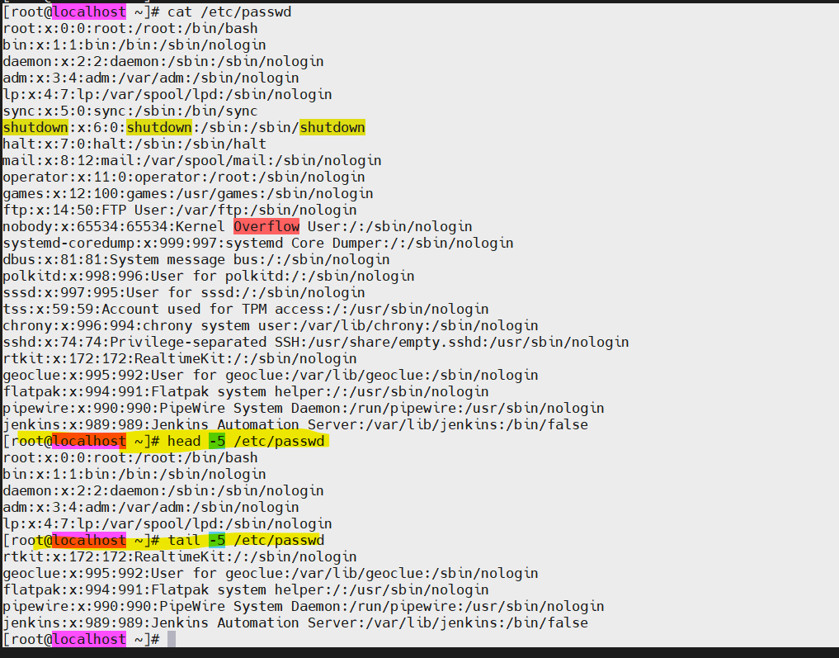

3. Searching for Patterns:

[root@localhost ~]# grep 'root' /etc/passwd
root:x:0:0:root:/root:/bin/bash
operator:x:11:0:operator:/root:/sbin/nologin
[root@localhost ~]# grep 'root' /etc/passwd | grep -i root
root:x:0:0:root:/root:/bin/bash
operator:x:11:0:operator:/root:/sbin/nologin
[root@localhost ~]#

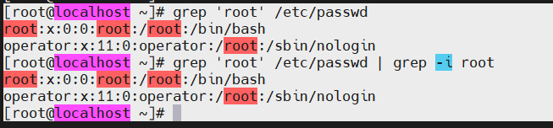

4. Zipping and Unzipping:

[root@localhost ~]# zip -r test_dir.zip test_dir
adding: test_dir/ (stored 0%)
adding: test_dir/renamed_example.txt (stored 0%)
[root@localhost ~]# ls -ltr
total 8
-rw-------. 1 root root 695 Aug 2 10:49 anaconda-ks.cfg
drwxr-xr-x. 2 root root 33 Aug 18 22:47 test_dir
-rw-r--r--. 1 root root 352 Aug 18 22:59 test_dir.zip
[root@localhost ~]#
[root@localhost ~]#
[root@localhost ~]# mkdir unzipped_dir
[root@localhost ~]#
[root@localhost ~]# ls -ltr
total 8
-rw-------. 1 root root 695 Aug 2 10:49 anaconda-ks.cfg
drwxr-xr-x. 2 root root 33 Aug 18 22:47 test_dir
-rw-r--r--. 1 root root 352 Aug 18 22:59 test_dir.zip
drwxr-xr-x. 2 root root 6 Aug 18 23:03 unzipped_dir
[root@localhost ~]#
[root@localhost ~]#
[root@localhost ~]# unzip test_dir.zip -d unzipped_dir
Archive: test_dir.zip
creating: unzipped_dir/test_dir/
extracting: unzipped_dir/test_dir/renamed_example.txt
[root@localhost ~]#
[root@localhost ~]# ls -l unzipped_dir
total 0
drwxr-xr-x. 2 root root 33 Aug 18 22:47 test_dir
[root@localhost ~]#

5. Downloading Files

[root@localhost ~]# wget https://google.com/index.html
--2026-08-19 19:40:13-- https://google.com/index.html
Resolving google.com (google.com)... 192.178.134.102, 192.178.134.113, 192.178.134.100, ...
Connecting to google.com (google.com)|192.178.134.102|:443... connected.
HTTP request sent, awaiting response... 301 Moved Permanently
Location: https://www.google.com/index.html [following]
--2026-08-19 19:40:14-- https://www.google.com/index.html
Resolving www.google.com (www.google.com)... 142.251.153.119, 142.251.157.119, 142.251.156.119, ...
Connecting to www.google.com (www.google.com)|142.251.153.119|:443... connected.
HTTP request sent, awaiting response... 200 OK
Length: unspecified [text/html]
Saving to: ‘index.html’

index.html [ <=> ] 83.10K --.-KB/s in 0.03s

2026-08-19 19:40:14 (2.73 MB/s) - ‘index.html’ saved [85090]

[root@localhost ~]#

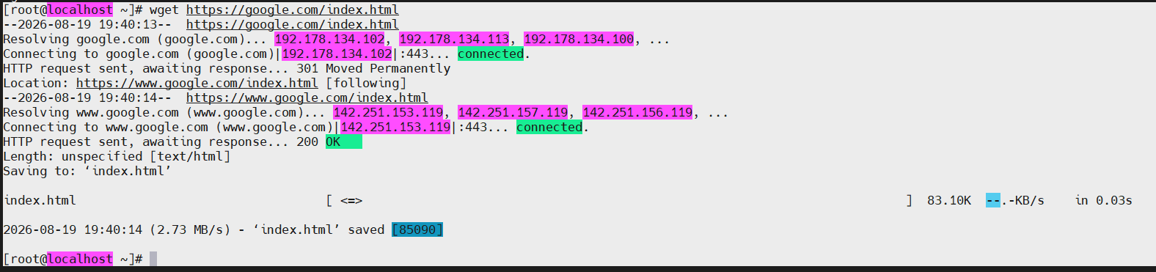

6. Changing Permissions

[root@localhost ~]# touch secure.txt
[root@localhost ~]# ls -ltr
total 92
-rw-------. 1 root root 695 Aug 2 10:49 anaconda-ks.cfg
drwxr-xr-x. 2 root root 33 Aug 18 22:47 test_dir
-rw-r--r--. 1 root root 352 Aug 18 22:59 test_dir.zip
drwxr-xr-x. 3 root root 22 Aug 18 23:03 unzipped_dir
-rw-r--r--. 1 root root 85090 Aug 19 19:40 index.html
-rw-r--r--. 1 root root 0 Aug 19 19:44 secure.txt
[root@localhost ~]# ls -ltr secure.txt
-rw-r--r--. 1 root root 0 Aug 19 19:44 secure.txt
[root@localhost ~]# chmod +r secure.txt
[root@localhost ~]# ls -ltr secure.txt
-rw-r--r--. 1 root root 0 Aug 19 19:44 secure.txt
[root@localhost ~]# chmod 444 secure.txt
[root@localhost ~]# ls -ltr secure.txt
-r--r--r--. 1 root root 0 Aug 19 19:44 secure.txt
[root@localhost ~]#

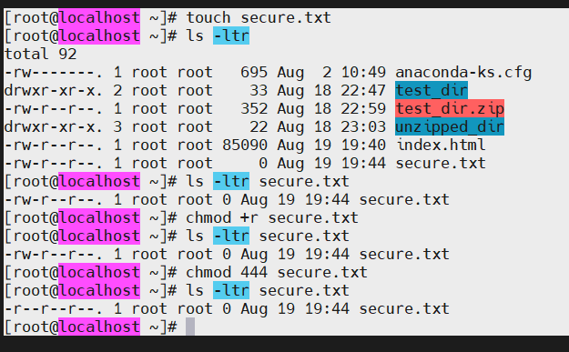

7. Working with Environment Variables

[root@localhost ~]# export MY_VAR="Hello, Linux!"
[root@localhost ~]# echo MY_VAR
MY_VAR
[root@localhost ~]# echo $MY_VAR
Hello, Linux!
[root@localhost ~]#

